INSETA - ASSESSMENT QUALITY PARTNER

External Integrated Summative Assessment EXAMPLAR

OCCUPATIONAL CERTIFICATE: INSURANCE CLAIMS ASSESSOR (99668)

LONG-TERM INSURANCE

QUESTION PAPER

Occupational Certificate – Insurance Claims Administrator (Insurance Claims Assessor)
SAQA ID: 99668 | NQF LEVEL: 4 | CREDITS: 131

DATE: |  | TIME: | 09h00-12h00
DURATION: | 3 hours | MARKS: | 100
EXAMINER: |  | MODERATOR:
INSETA PAPER SERIAL Number |  | LT2024/04/25CA
INSTRUCTIONS TO CANDIDATES:

- Answer all questions in Section A (30 marks)

- Answer all questions in Section B (55 marks)

- Answer all questions in Section C (15 marks)

- This is a closed book examination.

- No written material may be brought into the examination room

- ONLY reference materials supplied with the examination paper may be utilised to answer the questions.
- The use of a calculator is permitted.

- Write legibly and neatly.

- Do not turn over this page until permitted by the invigilator.

SECTION A
LT2024/04/25CA – Case Study 1
Candidates Are Required to answer ALL questions in this section.

2024/04/25-(CS:01)
CASE STUDY 1
Study the Membership certificate attached below and answer the questions that follow:
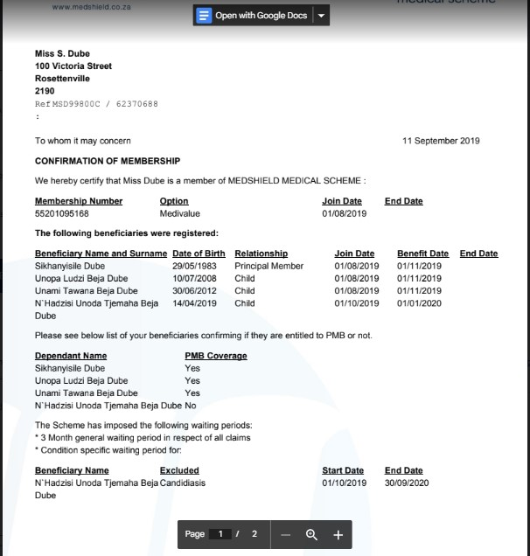
Delan Martins
Jane Martins
Leo Martins
Anna Martins
Delan Martins
Jane Martins
Leo Martins
Anna Martins
Delan Martins

PRESCRIBED MINIMUM BENEFITS (PMB): The Scheme will cover the cost related to the treatment of certain minimum health services for certain conditions.

CONTRIBUTION:
The breakdown of your monthly contribution is as follows: Contribution: R 2,970.00
The Total Contribution amount of R 2,970.00 is payable from 01 September 2019.

  - Determine the following from the membership certificate: [4 marks]
  - The policy effective date
  - The amount of premium paid by the insured
  - The principal member
  - The dependents’ details
  - Explain the consequences Thandi might face for not paying premiums. [ 4 marks]

  - Jane missed her first premium payment date on the 1st of September 2019.Explain how any claims submitted after the non-payment of her monthly contribution will be treated.
[2 marks]
Question 2 [10 marks]
Study the policy document for Live4Health Insurance attached below and answer the scenarios that follow:

Live4Health Insurance Pure life policy document

Benefit:
This product pays out the sum assured in the event of the death of the life assured. The amount that will be paid out is stated on your policy schedule and is subject to all the conditions of this contract being met.

Expiry of cover: Your life cover is a whole of life cover; cover will cease in the event of the death of the life assured, however the policy will automatically expire if it becomes invalid for any other reason.

Waiting period: The waiting period will be as set out in your policy schedule. During this period, only accidental death claims will be admitted.

HIV testing: Your insurer may require a new negative HIV test on the life assured to be submitted, as specified in your policy schedule or amendment schedule. HIV testing may be required within a specified time frame from date of commencement, policy upgrade and/or reinstatement of cover.

Should this not be supplied within the required period or the test result is reactive, the life assured will automatically be covered for accidental death and accidental disability (if applicable) only.

Dread disease cover (if applicable) and Terminal Illness benefit will fall away and premiums may be adjusted accordingly. Should the HIV test result be received after the required date, underwriting may be required to review any benefits on the policy.

Additional benefits
Depending on your policy, one or more of these benefits may be added to your contract. Please refer to your policy schedule for confirmation of the benefits that have been included. •
- Terminal illness cover: If the life assured is diagnosed with a terminal illness and your insurer’s medical officer confirms a life expectancy of no more than 12 (twelve) months, payment of the sum assured will be made. Thereafter, all benefits under this product will cease. This cover will not be applicable if the waiting period has not yet expired.
- Pay-now accelerated death benefit: An accelerated death benefit is available for funeral and other related expenses in the event of the death of the life assured. Your insurer pays the benefit from the life cover sum assured to the nominated beneficiary on the policy, who is responsible for the cost of the funeral. The balance of the claim will be assessed and settled thereafter, provided the terms and conditions are met. Should a beneficiary not be nominated on the policy or if the beneficiary/ beneficiaries are minors at the time of claim, the pay-now accelerated death benefit will not apply and the full sum assured will be paid to the estate or relevant registered

- trust upon finalisation of the claim, provided all the terms and conditions are met. The benefit is only available after six (6) months for death due to accidental causes and after twelve (12) months for death due to natural causes, from commencement or reinstatement effective date of cover provided the first premium was received.
- Premium waiver: If applicable to the product chosen, if the life assured becomes disabled and is paid a 100% lump sum disability benefit, the premiums for pure life cover and dread disease cover (if applicable) will not be charged for a period of 5 (five) years. Policy premium collection re-commence and is payable again when the premium waiver period has expired. After this period, normal cancellation rules will apply as stated above.
- Guaranteed assurability: If applicable to the product chosen, the life cover sum assured on the policy may be increased by a percentage of the original sum assured, up to a maximum allowed or up to your insurer’s maximum insurable amount at the time, whichever is lower. This is without the need for any further underwriting, other than providing a new negative HIV test for the life assured. Such an option may only be exercised on every third policy anniversary or after a significant event, as described below:
  - the marriage of the life assured;
  - a child being born to or legally adopted by the life assured;
  - the life assured purchasing a home; and/or
  - the life assured entering into a business or taking an increased interest in an existing business. If cover is increased after any of the above events, the sum assured will remain the same for a period of three years and further guaranteed assurability increases will

only be allowed after this period, as stated in the policy schedule. You may only use this benefit if you:
  - have not claimed and are not in the process of claiming;
  - are not aware of any condition present and have not suffered any event that would entitle you to claim under a policy;
  - request the increase within 3 (three) months of the date of the significant event or third policy anniversary; and
  - are younger than the maximum entry age for this benefit. Your insurer may need further information about the significant events described above when you request the cover increase. Financial underwriting may also be required. Your insurer will base the premium for the increased cover on current premium rates and conditions applicable at the time of the increase.

General exclusions
Your insurer will have no liability whatsoever under the policy where any claim arises from, or is the result of the:
- death of the life assured, being, in the supplier’s opinion, as a result of the client’s own act, within 2 (two) years or 24 (twenty-four) months from the commencement date of the policy or the effective date of the cover, as stated in the policy schedule. If the sum assured is increased, a new 2-year (two year) period will apply to the increased portion, effective from the date of increase;
- policyholder/owner/life assured/beneficiary/ premium payer deriving or standing to derive any financial benefit or gain from the contravention of any law (including, but not limited to fraudulent activities);

- participation by the life assured in any criminal activity;
- the life assured wilfully and materially breaking any law; or the claim event having been accelerated by the life assured materially breaking any law; or excessive consumption of alcohol; intentional inhalation of fumes; or intentional and negligent consumption of poisons, drugs, narcotics or medication (unless prescribed by an independent medical practitioner and used according to these instructions) by the life assured. In the event of such a claim, the policyholder/owner will forfeit all benefits afforded in terms of this policy and all premiums paid in respect of this policy, and your insurer may void or cancel this policy as from the commencement date, at its discretion.

Specific exclusions
Your insurer will not pay a claim if the death of the life assured was, in their opinion, related directly or indirectly to any one of the events or conditions listed in the policy schedule under the Specific exclusions section.
  - Scenario 1
Zanele was offered a universal life policy on condition that she takes an HIV test by the 1st of August 2023, failure to which her policy pays only on accidental death. Zanele forgot to take a test until the 10th of November, 2023. If all premiums had been paid on time as agreed, explain how the insurer would have treated her death claim if she passed from Covid related complications on the 1st of December 2023? [4marks]

  - Scenario 2
Assume John had paid all his premiums on time and complied with all policy terms and conditions for cover. He died from alcohol poisoning on the 23rd of December 2023 after attending a Christmas work party. How would the insurer treat this claim? [2 marks]
  - Scenario 3
When taking out the life policy, Phiwe answered ‘No’ to the following question:
‘In the last 2 years, were you prescribed chronic medication for more than 2 weeks or been hospitalized for more than 4 nights? ‘
On investigation, when she had passed on from respiratory complications, you discover that Phiwe had suffered from asthma the whole of her life. How would you handle this claim?
[2 marks]
  - Scenario 4
Mendy took out a life policy in December 2023. On the 4th of Aoril Mendy committed suicide and a claim was submitted. Explain how you would treat this claim? [ 2 marks]
Question 3 [10 Marks]

3.1 Muzi works as a forklift driver and has a life policy that covers him for R1 000 000, with R750 000 accelerated benefit for disability.

The pay-out schedule for disability claims following a loss of a limb is as follows:
Definition | 50% pay-out | 100% pay-out
Loss of or Loss of Use of Limbs: The permanent physical severance of a limb from above the elbow or knee joint or the total, permanent and irreversible loss of muscle function and sensation of the whole of a limb | One limb | Two limbs

Muzi has an accident at work and his left leg is amputated in the process.
Show how this claim will be treated, and explain the impact it has on his life insurance cover:
[6 marks]

3.2 Study the claims statement below for a healthcare claim and answer questions that follow:

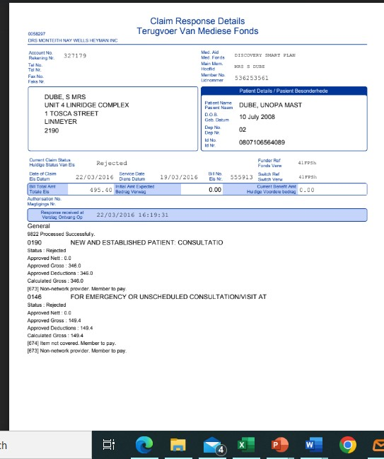

- What was the total claimed for by the member? How much did the client have to co pay for this claim? [2 marks]

- What could be the possible reason for this co-payment? [ 2 marks]

Section A: Total Marks = 30
SECTION B
LT2024/04/25CA – Case Study 2
Candidates Are Required to answer ALL questions in this section.
2024/04/25-(CS:02)
CASE STUDY 2
Question 1 [15 Marks]

1.1 Name and explain any 5 documents/details that are needed when processing a death claim.
[10 marks]
  - Besides documents/ details discussed in question 1a above, what other internal checks should you make as part of claims processing? [5 marks]

Question 2 [10 marks]

Use the policy schedule and document attached to answer these questions:

2.1 According to the Live4Health Insurance Whole Life policy document attached in Section A, what is the prescription period for payment of a terminal illness claim? [1 mark]

  - Lwazi takes out a whole life policy and fails to take an HIV test by the 4th of August as prescribed timeframe by the insurer. The policy states that any failure to take an HIV test will result in insured being covered for accidental death only, provided the insured dies within 180 days of the incident. On the 15th of November, he suffers a burglary in his house where he is shot and is hospitalised until he passes on the 4th of April 2024 from the gun shot injuries.
Explain the impact of the accidental death time frame on this claim. [3 marks]

  - According to the Live4Health Insurance Whole Life policy document attached in Section A, what is the prescription period for pay now accelerated death cover? [2 marks]

  - How would you have treated a claim for death if an insured she committed suicide just 5 months after the inception of the policy? [2 marks]
  - Menzi submits a claim for a serious heart condition. The doctor that diagnosed Menzi submits medical evidence that in all probability he has 15 months to live. Explain the impact of the terminal illness prescription period on this claim according to the ABC Insurance Whole Life policy document? [2 marks]

Question 3[30Marks]
3.1 Explain the type of medical information that a claims assessor may request from the medical doctor as part of a claims validation process: [ 5 marks]

Calculate the amount payable of the claim in the following scenarios:

3.2 Scenario 1
Mary purchases a standalone terminal illness cover for R250 000 and a whole life policy for R1 000 000 from Livewell Insurance company. Some years later, Mary suffers a serious heart attack and claims R250 000 from ABC life Insurance company.
Calculate the impact of this claim on his whole life policy? [3 marks]

3.3 Scenario 2
John purchases a whole life policy for R2 000 000, with full accelerated serious illness cover from LayaHealth Insurance company. Some years later, Mary suffers a serious heart attack and claims R2 000 000 from LayaHealth Insurance company.
Calculate the impact of this claim on his whole life policy? [3 marks]

3.4 Scenario 3
Peggy purchases a whole life policy for R3 000 000, with R7500 000 accelerated serious illness cover from South Insurance company. Some years later, Peggy suffers a serious heart attack and claims R750 000 from South Insurance company.
Calculate the impact of this claim on his whole life policy? [3 marks]

  - Assume that Litha has a disability policy for R500 000.
The pay-out schedule for disability claims following a factory incident that left the insured with serious burns is as follows:
Definition | 50% pay-out | 100% pay-out
Major Burns: Burns that involve damage or destruction of the skin to its full depth through to the underlying tissue and covering a minimum specified body surface area percentage | Full thickness burns covering at least 15% of body surface area. | Full thickness burns covering at least 20% of body surface area

If the insured suffered 10% burns of body surface area, show how this claim will be treated, and explain the impact it has on her life insurance cover: [ 4 marks]

  - Study the pay-out for Nathi’s claim below for serious illness.

Disease | Life Changing Event Level 1 – 25% Pay-out | Life Changing Event Level 2 – 100% Pay-out
Cancer Any malignant tumour characterised by the uncontrolled growth and spread of malignant cells and invasion of tissue. Unequivocal histological evidence of invasive malignancy must be provided. | Stage 1 or Stage 2 cancer or diagnosis of leukaemia. | Stage 3 or Stage 4 cancer or recurrence (relapse) or persistence of leukaemia despite treatment.
Survival period | 14 days from the date of diagnosis.
Dread disease cover | R750 000

- Assume Nathi is diagnosed with stage 2 cancer. How much will he receive for this claim?
[ 3 marks]
- If he later suffers from a more severe attack, and survives for 20 days after the event. How much will he receive? [4 marks]

- What would have happened had he suffered from a more severe attack and survived for 6 days?

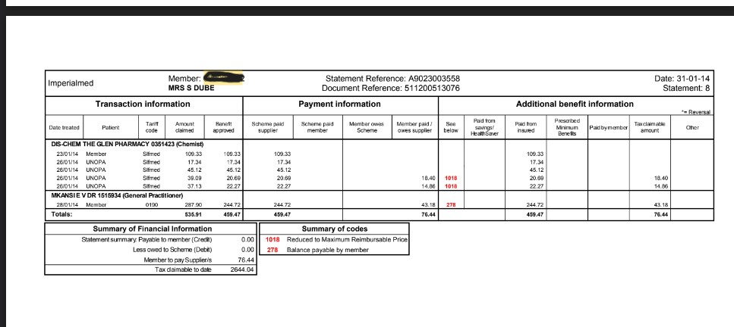
  - Study the claims statement below and answer the questions that follow:

- From the statement above, how much was paid by the scheme? What was the member’s portion? [2 marks]

- What was the reason for non-payment of the whole amount by the scheme? [1 mark]

Section B: Total Marks =55

SECTION C
LT2024/04/25CA – Short Answer 3
Candidates Are Required to answer ALL questions in this section.

2024/04/25-(SA :03)
Question 1
Liz recently claimed for a Level 1 stroke payment from her Serious Illness policy. Liz drinks every weekend and is a chain smoker. Discuss any 5 risk improvement recommendations that you can make to Liz and the insurer going forward? [10 marks]
Question 2
Discuss any 3 possible decisions that can be made by a claims processor when validating a claim such as the one above? [5 marks]

Section C: Total Marks = 15

Overall Question Paper Total = 100

Section A: Case Study = 30

Section B: Short Answer 1 & 2 = 55

Section C: Short Answer 3 = 15

